Why do some plants grow in odd shapes?

Watch the video at https://www.youtube.com/watch?v=jJrqmkbiwdE. Use the information from this video to interpret the growth of plants inside the plant maze shown below. For almost all the time, the cardboard doors were kept closed, so the hole in the top of the maze was the only source of light for the plants in the maze.

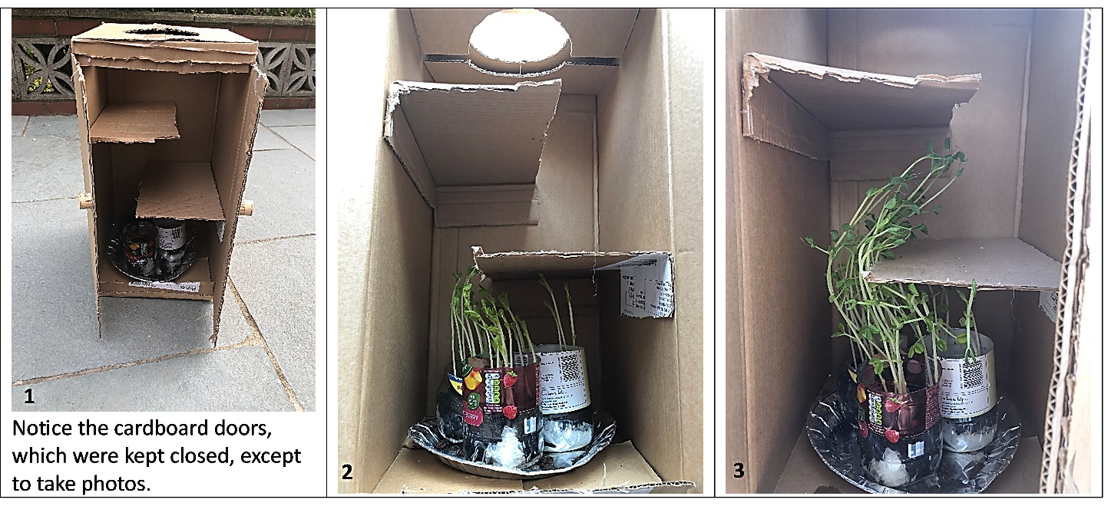

1. In the third photo, sketch how you think the tallest plants will continue to grow.

2. What processes do you think resulted in the bends in the stems of the plants in the video and in the plant maze? Describe or diagram as many steps as you can think of.

3. Explain why it is useful for plants to grow toward light.

To understand how plants grow toward light, you will need to know how plant stems grow taller. New cells are produced by cell division in a zone at the tip of a growing stem. Just under that is a zone where the new cells elongate (get longer).  4. How do microscopic cellular processes cause a plant stem to grow visibly taller? | Stem Tip Seen Through a Microscope  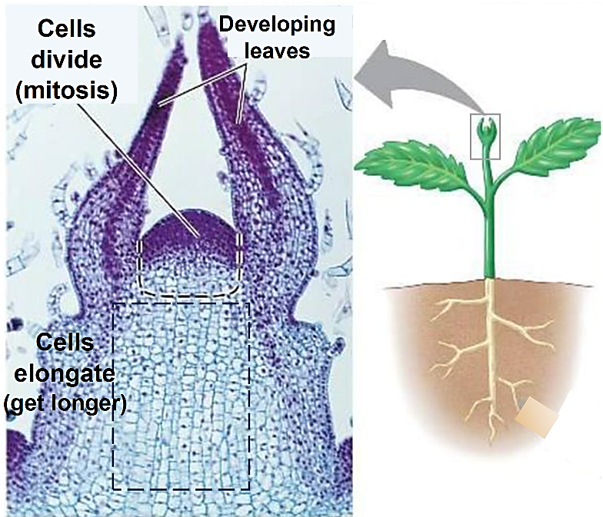
This figure summarizes the results of several studies that investigated how plants bend toward the light. As each of these plants grew, the light came from the left.

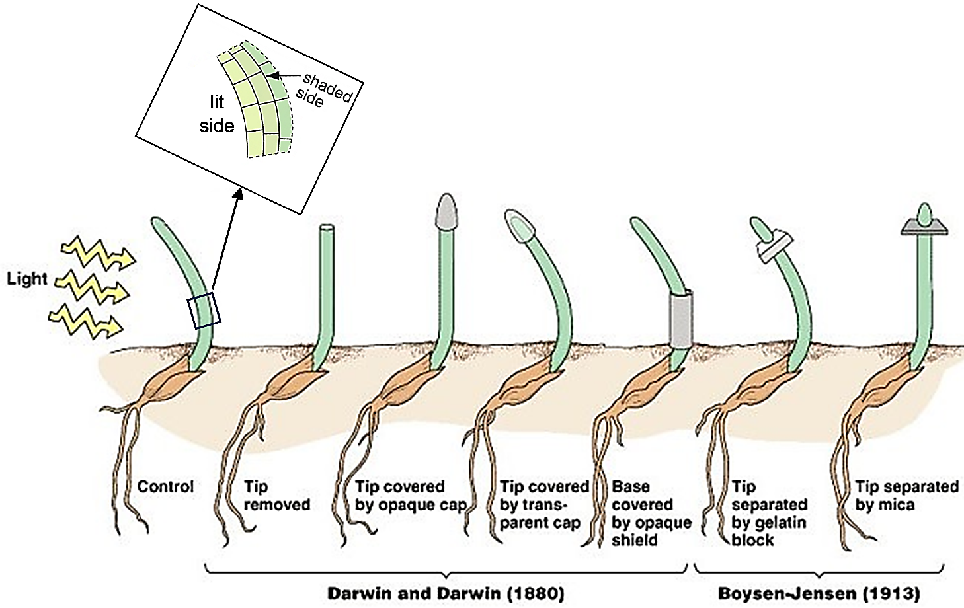

5a. The inset diagram shows a magnified view of the bent part of the first plant. Which side of the bend has longer cells? What can you conclude about how a growing plant bends toward light which comes from one side?

5b. What can you conclude from the four drawings that show the results of the experiments by Darwin and Darwin?

5c. What can you conclude from the last two drawings, which show the results of the Boysen-Jensen experiments? (Hint: Gelatin, but not mica, allows molecules to diffuse from the tip to the rest of the stem.)

More recently, biologists have discovered several relevant facts. The tip of a plant stem makes the plant hormone, auxin. If light comes from one direction only, then more auxin flows down the shaded side of the stem. Auxin stimulates elongation of cells in the stem.

6. Use the information on this page to describe or diagram the steps that cause a growing plant stem to bend toward light coming from one direction.

You will need additional information to interpret the next example of a plant with an odd shape (shown on the next page). The figure on the right shows that the tip of a growing root has zones where cells divide (3) and elongate (2). Just above those is a zone where cells differentiate into the specialized cells that a plant needs to function (1). (A growing stem also has a zone of cell differentiation, just under the zones of cell division and elongation.)  Most of the cells in a plant are differentiated cells. Differentiated cells do not divide or elongate.  7a. Roots and stems grow longer:  - all along the root or stem.  - only near their tips.  7b. What information supports your answer?  The first figure below shows differentiated cells that are specialized to transport water with dissolved substances. Each vessel in xylem or phloem is a | The root cap protects the growing root tip as it pushes through the soil. Root hairs increase surface area to absorb more water.
column of specialized cells that facilitate fluid flow.

The second figure below shows a section of a leaf, with xylem cells, phloem cells, and another type of differentiated cell that contains multiple chloroplasts where photosynthesis takes place.

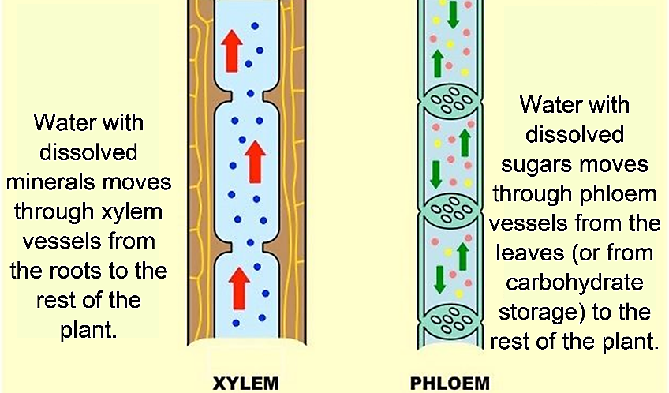 | 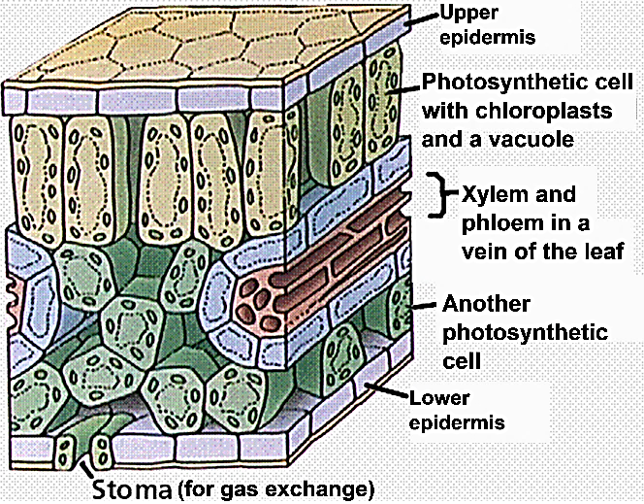

8. Why do plant leaves need to have xylem?

9. Why is it useful for plant leaves to have phloem?

10. Complete these sentences to illustrate the general principle that biological structures often contain multiple repeats of smaller structures. To fill in each blank, use cells, chloroplasts, or leaves.

Plants have multiple ______________, each of which contains many ______________. One type of leaf cell contains multiple ___________________, which carry out photosynthesis.
11. Watch the video at https://www.youtube.com/watch?v=d26AhcKeEbE&t=21s. At the beginning, when the seeds sprouted underground, the roots grew down and the stems grew up. What stimulus do you think the stems and roots were responding to?

12a. What is odd or unusual about the shape of the plant that kept growing after it fell over?

12b. What sequence of steps do you think caused this odd shape?

In the plant that had fallen over, the hormone auxin was transported to the bottom side of the growing stem and root. Auxin has opposite effects on cell elongation in the stem vs. in the root.

13a. Match each statement with the correct picture.  - In a growing stem, auxin stimulates cell elongation, so the stem bent up. ___  - In a growing root, auxin inhibits cell elongation, so the root bent down. ___  13b. Draw an arrow from each of these figures to the corresponding part of the figure above. | A 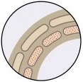 | 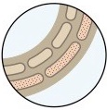  B

14a. Explain why the plant that had fallen over had a horizontal section between the vertical parts of the stem and the main root. (Hint: Remember that differentiated cells don’t elongate.)

14b. Describe or diagram the steps that resulted in the odd shape of the plant that kept growing after it fell over. (A complete answer will include cell elongation and differentiation and the effects of gravity, light, and auxin.)

There are several other plant hormones in addition to auxin. Interactions between plant hormones can result in odd shapes in some plants. For example, as a potato plant matures, several hormones stimulate the development of underground potatoes, so underground a mature potato plant has an unusual appearance.

This figure shows asexual reproduction of a potato plant. An old potato sprouts and sends a shoot upward (1). This shoot grows taller and develops leaves (2-3). Photosynthesis in leaves produces sugars which are stored in starch molecules in new potatoes (4-6).  15a. How are the starch molecules in a potato useful for asexual reproduction? | 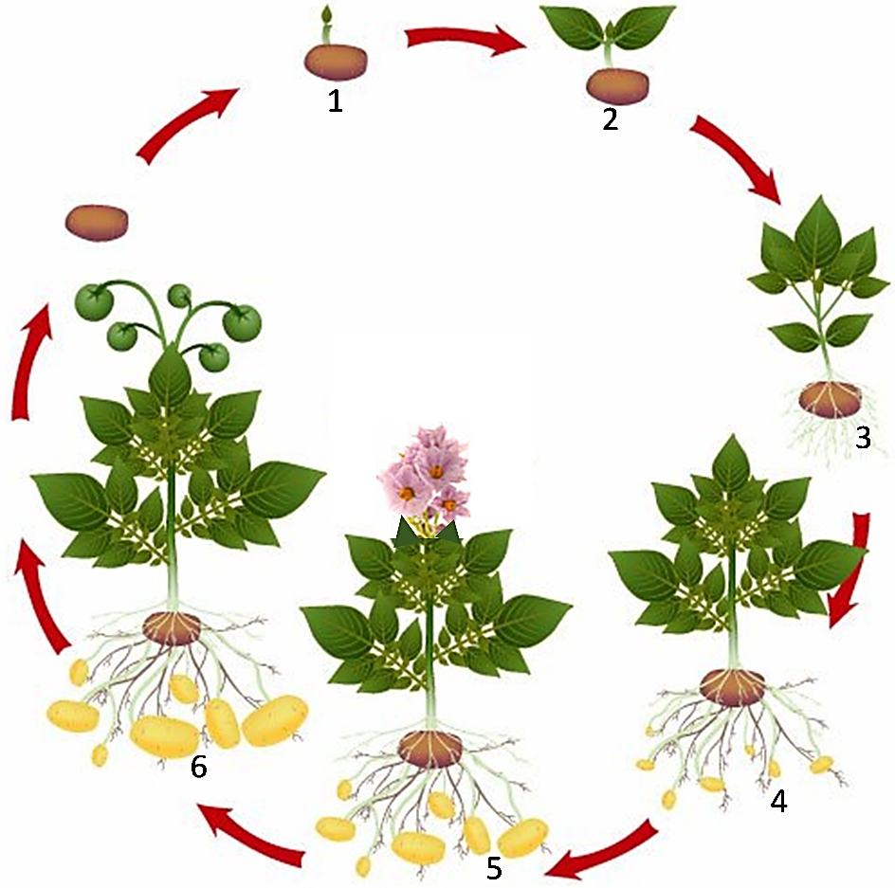

15b. Each potato is connected to the potato plant by an underground stem. These underground stems are longer in a wild potato plant (2-4 feet), compared to a farm potato plant (only 1-5 inches). Explain how these longer underground stems contribute to successful asexual reproduction of wild potato plants.

16. The same stimuli and processes that can result in odd shapes also contribute to the growth of more typical plants. Describe the stimuli and processes that have contributed to the growth of the plant in this drawing. (A complete answer will include cell division, cell elongation, cell differentiation, light, gravity, and auxin.)

By Dr. Ingrid Waldron, Department of Biology, University of Pennsylvania, © 2023. This Student Handout and Teacher Notes with background information and instructional suggestions are available at https://serendipstudio.org/exchange/bioactivities/plant.

